Faculty Database

By

Ishan Mukharjee(91/CIS/091011)
Juhi Meheta(91/CIS/091026)
Dipendu Ghosh(91/CIS/091007)
Hirakjyoti Banarjee(91/CIS/091012)
Sambuddha Das(91/CIS/091008)

Project done under the guidance of
Prof Shankhayan Chowdhury



Department of Computer Science and Engineering,
Rajabazar Science College
Acknowledgment:

Table of Contents:

Chapter: One
Problem Definition

- Problem Definition:

Develop a faculty database system which will maintain all the details about the faculties of a particular university. It should be able to provide the following details-

- Personal details of a particular faculty. Such as name, date of birth, date of joining, qualification, home address, phone number(s), email account, photo etc.

- Conference details, i.e details about the conferences attended by different faculties. Such as conference name, conference type, starting date, finishing date, place, venue , central idea, venue type ( national / international ).

- Project details. Such as project name, topic, name of the project head, name of the organization that will fund the particular project, type of project(R&D/Commercial), stating date, finishing date and completion status.

- Publication details. Such as- publication topic, read in conference, volume number, author, journal number and publication date.

- Patent details. Such as- Patent number, topic, patent owner's name, date.

Chapter: Two
Requirements Analysis
& Specification

Software Requrements & Specifications:

- T1: Personal Details

Description: This module keeps the personal details of the teaching faculty.

T1.1: Enter the personal details/modify the details.
Input: Select “Create New“/“ Modify Existing“ options.
Output: The Initial Empty form, to enter the data / The final filled form to be updated.

T1.2: View all teacher Details.
Input: Select “View all“ option.
Output: Show all the teachers details in table form.

T1.3: View specific teachers details.
Inpeut: Enter teacher name.
Output: Show that perticular teacher details.

- T2: Conference

Description: This module keeps the details of the conferences attended by different teaching faculties.

T2.1: Enter/ Modify conference details.
Input: Select “New Conference“ option.
Output: 1) date wise details
2) details per faculty

- T3: Projects

Description: This module keeps the details of the projects done under different teaching faculties.

T3.1: Enter/ Modify project details.
Input: Select “Enter New Project“ option.
Output: Show the “Project Details“.

T3.2: Show the projects under a specific faculty.
Input: Enter the name of that specific faculty.
Output: Show the list of projects under that specific faculty.

T3.3: Show the projects funded by a perticular organization.
Input: Enter the name of that perticular organization.
Output: Details of the projects under the entered organization.

- T4: Publications

Description: This module keeps the details of the publicastions done by different teaching faculties.

T4.1: Enter/ Modify the publication details.
Input: Select “Enter New Publication“ option.
Output: Shows the empty form.

T4.2: Shows the list of publications done by a specific faculty.
Input: Enter the name of that specific faculty.
Output: Show the list of publications done by that specific faculty.

- T5: Patents

Description: This module keeps the details of the patents taken by different teaching faculties.

T5.1: Enter/ Modify the patent details.
Input: Select “Create New Patent Entry“ option.
Output: Shows the empty form to enter patent details.

T5.2: Shows the list of patents taken by a specific faculty.
Input: Enter the name of that specific faculty.
Output: Show the list of patents taken by that specific faculty.

Chapter: Three
Logical Design

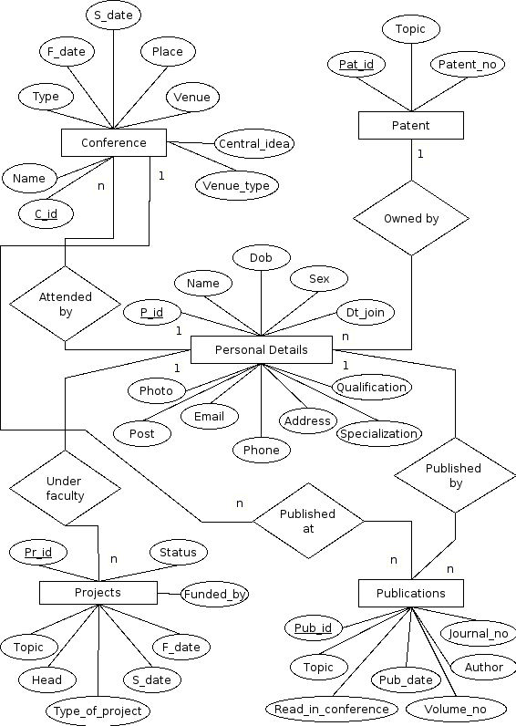

- ERD description:

Different Entities:

1. Personal_details: Personal details of a particular faculty. Such as name, date of birth, date of joining, qualification, home address, phone number(s), email account, photo etc.
2. Conference: Details about the conferences attended by different faculties. Such as conference name, conference type, starting date, finishing date, place, venue , central idea, venue type ( national / international ).

3. Projects: Such as project name, topic, name of the project head, name of the organization that will fund the particular project, type of project(R&D/Commercial), stating date, finishing date and completion status.

4. Publication: Such as- publication topic, read in conference, volume number, author, journal number and publication date.

5. Patent: Such as- Patent number, topic, patent owner's name, date.

Different Relations:

- Attended by: This is the relation between tables conference and Personal details. It is a many to one relationship.

- Published at: It is a one to many relationship between Conference and Publication.

- Published by: It is a many to one relationship between Publication and Personal Details.

- Under faculty: It is a many to one relationship between Projects and Personal details tables.

- Owned by: It is a many to one relationship between tables Personal details and Patents.

- Schema Description:

- Personal_details: PD_pid, name, DOB, date_of_joining, qualification, home address, phone, email, photo.

- Conference: C_id, Conference name, conference type, starting date, finishing date, place, venue , central idea, venue type ( national / international ).

- Projects: Pr_id, project name, topic, head, funded_by, type, stating_date, finishing_date and completion_status.

- Publication: Pub_id, publication topic, read in conference, volume number, author, journal number and publication date.

- Patent: Pat_id, Patent_number, topic, name, date.

Chapter: Four
Project Description

- Data Insertion forms:

- Form 1:
Top of Form
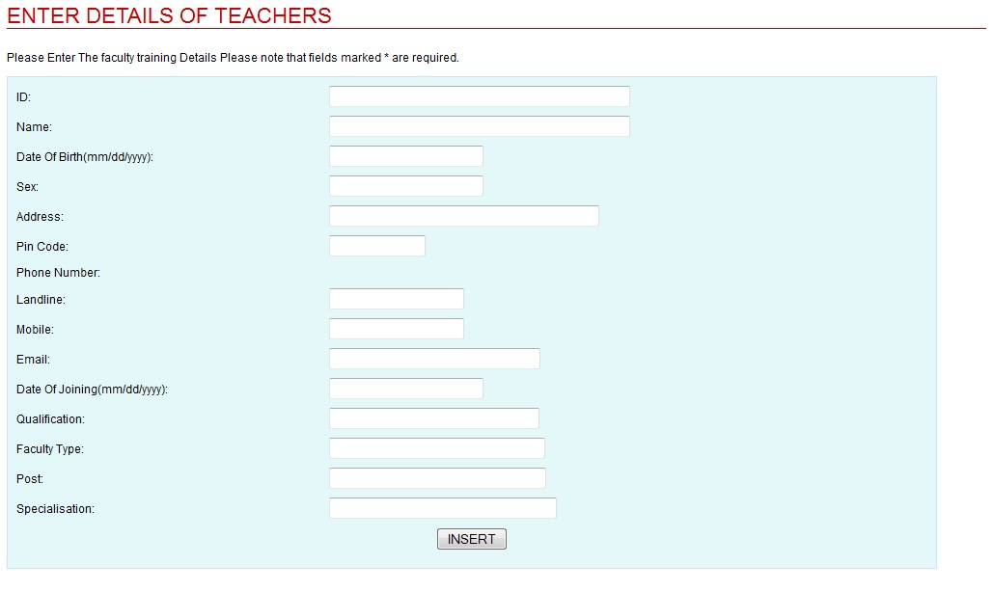

Personal Details: This form is used to insert data into the personal_details table. Name, Date of birth, sex, address, Phone number (Landline and Mobile), email account, Date of join, qualification, Faculty type, Post, Specification etc fields.

- Form 2:

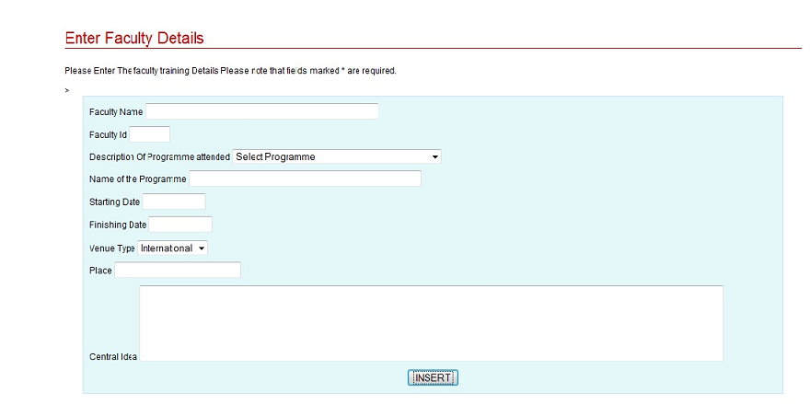

Conference: This form is used to insert details about the conferences attended by different faculties. Such as conference name, conference type, starting date, finishing date, place, venue , central idea, venue type ( national / international ).

- Form 3:

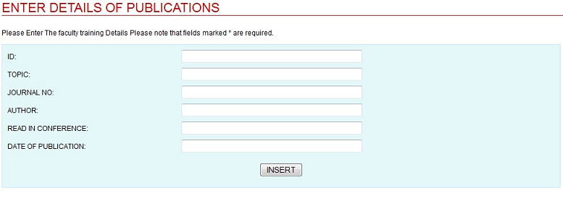

Publication: This form is used to insert data into the fields such as- publication topic, read in conference, volume number, author, journal number and publication date.
- Form 4:

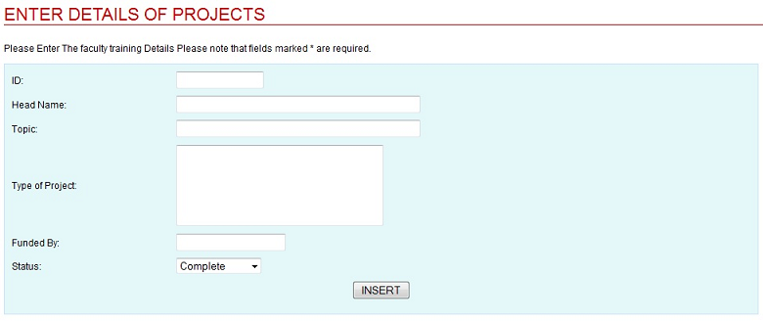

Projects: Such as project name, topic, name of the project head, name of the organization that will fund the particular project, type of project(R&D/Commercial), stating date, finishing date and completion status.

- Form 5:

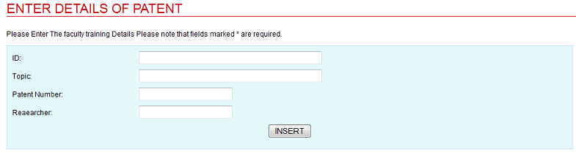

Patent: This form is used to insert data into the fields such as- Patent number, topic, patent owner's name and date.

- View forms:

- Form 1:
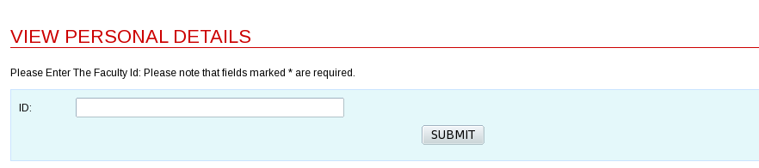

In this form, we can retrieve information about a faculty by entering his

